Lab methods for Hyperspectral Measurements
Jasmine Ryan and Shina Lohman
December 9th, 2024

Goal:
Collect hyperspectral readings of biological soil crust using the “Analytical Spectral Devices” (ASD) instrument.

Instrument Set Up:
- Turn instrument on (switch in the back)
- Allow instrument to warm up for at least 20 min with light probe turned on (click power button once on light probe)
- While warming up instrument, set up your excel data sheet to associate files name and number to sample ID
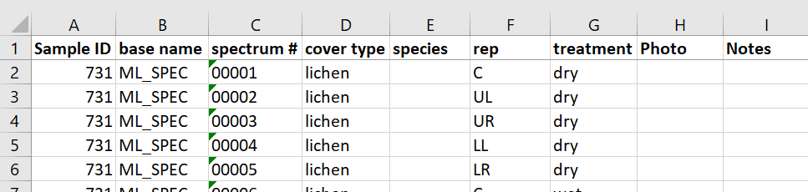

- Connect instrument to Bill’s field computer (or computer with correct software downloaded) using ethernet cable
- Open RS³ software
  - It should say instrument connected at the bottom right, if not, unplug and plug it in again and relaunch software
- Save locations/file naming convention
  - Click “Control” tab in upper left window → spectrum save
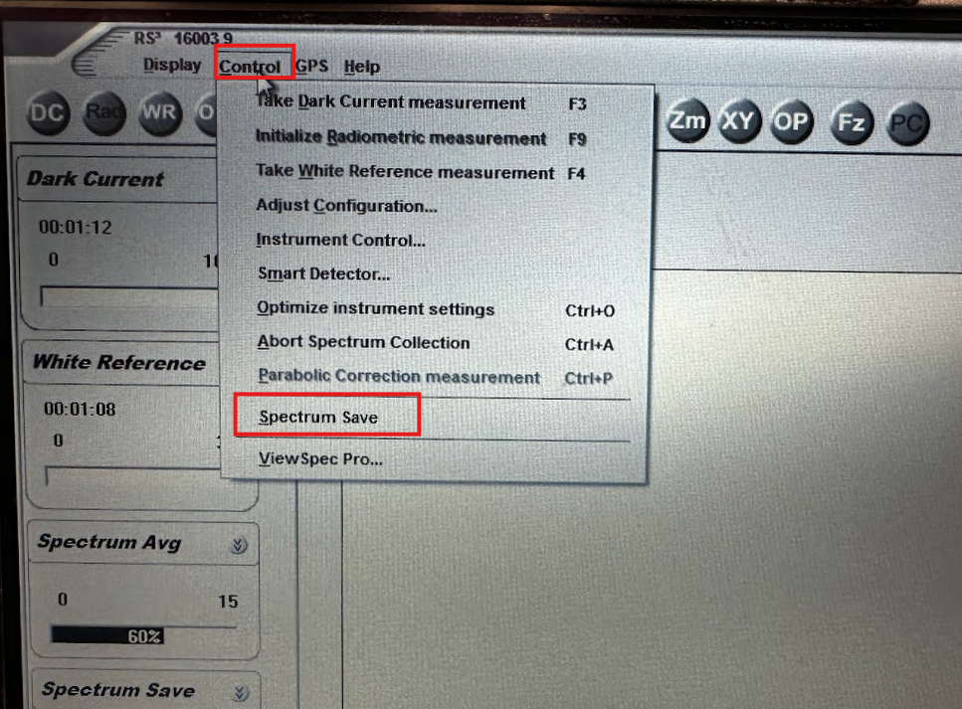
    - Number of files to save: 00001
    - Start file number: 00001
    - Interval between saves: 00:00:00
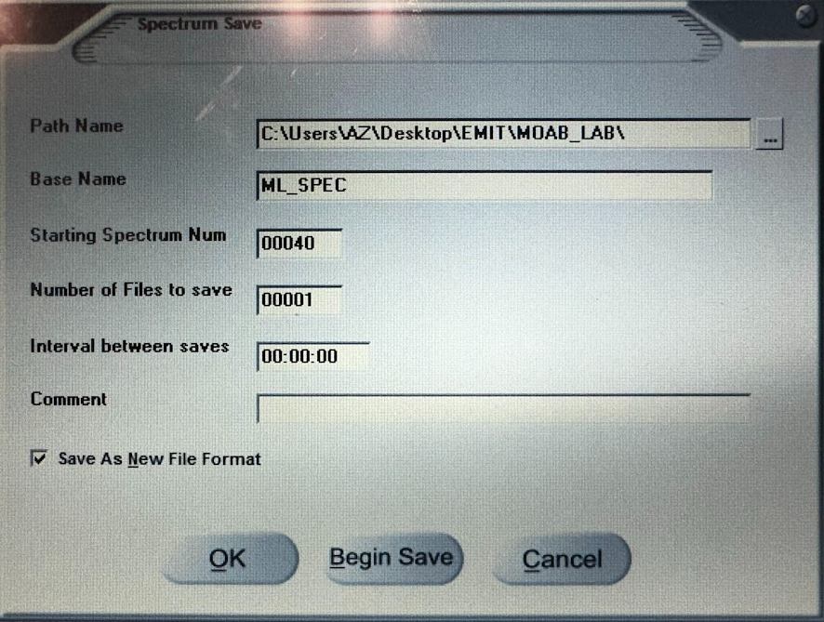
Note: This photo shows starting spectrum num as 00040, for a new project start at 00001
    - Path Name: Where you want to save the files to. Browse a location with the “...”
    - Base Name: The base name of all files being saved
      - This would be the name of the site or project – for example here we are using “ML_SPEC” to denote “Moab Lab Spec” as the project
    - Starting Spectrum Number: the unique number that follows the base name of each file
      - This would be like the unique collection ID number – there will be multiple ID numbers for each sample
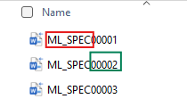
- Instrument Calibration:
  - Turn lights off in work space (close doors if necessary to reduce light noise)
  - Using the white reference strips provided, place contact probe flush against strip(s) (Avoid touching the contact strips with your hands, use tweezers)
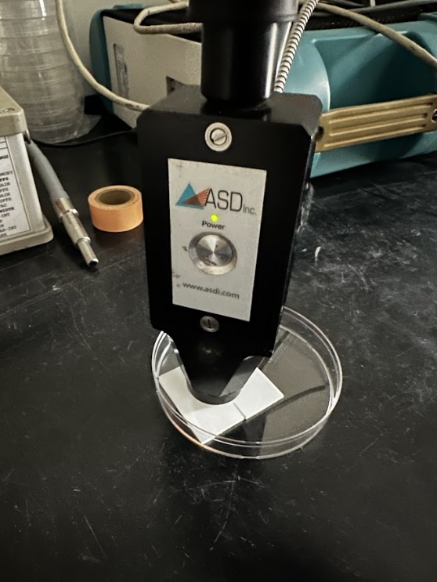
Note: we used two white reference strips next to each other to create a better seal with the light probe.

  - Click “OPT” (optimize) in upper left corner of window
    - The spectrum should shift if done correctly

Before Optimizing: After Optimizing:
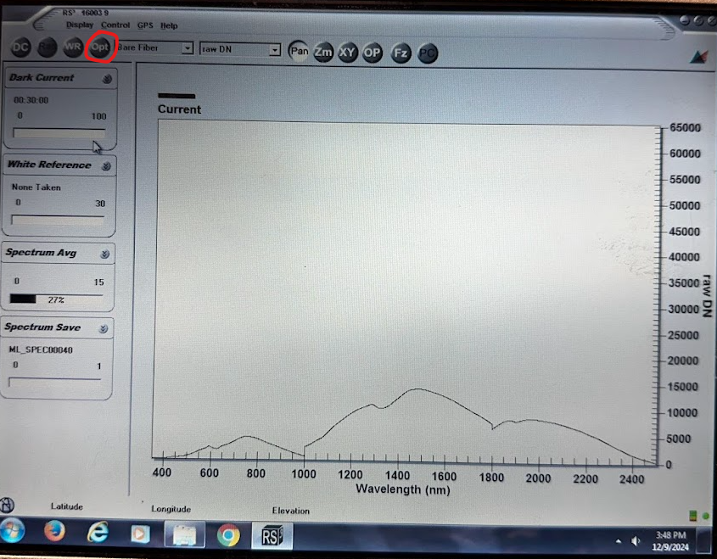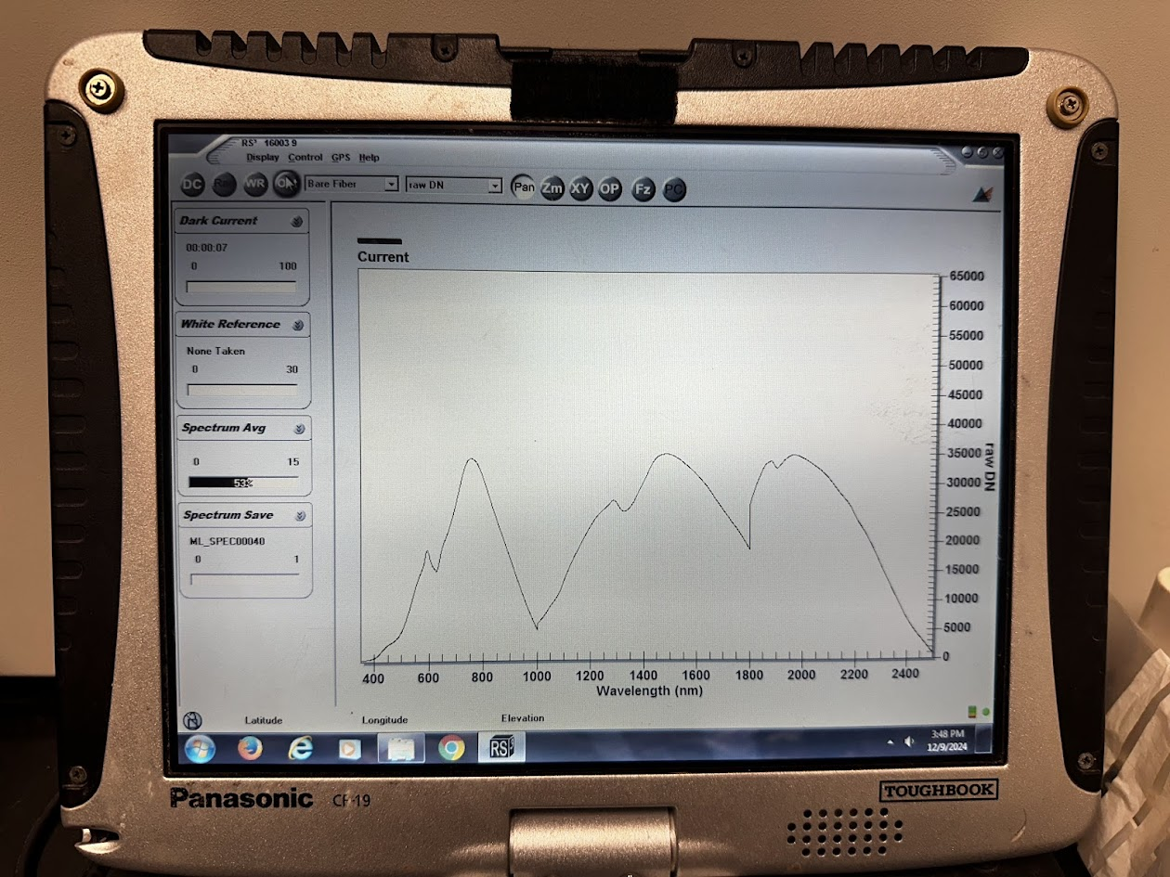

  - With the probe still in full contact with the white reference strips, click “WR” (white reference) in upper left corner of window (recalibrate with white reference every few samples or if the straight reference line looks irregular. Might have to reoptimize as well)
    - The spectrum should look like a straight line and the y-axis should change to “reflectance”
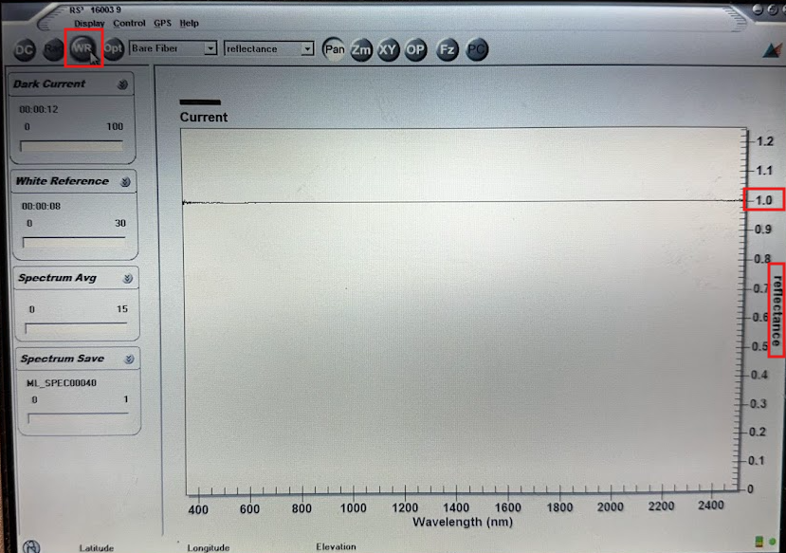
    - Probe in contact with reference strip: should be straight line across “1” on the y-axis
    - Probe in contact with black background (fully absorbent surface): should be straight line across “0”

Recording Readings:
- Take photo number 1 of biocrust sample in collection tube
  - Record photo number or label photo on phone
- Remove sample from collection tube, place on plastic petri dish (60mm x 9mm) against black background (black lab bench in this case)
- Take photo number 2
  - Record photo number or label photo on phone
- Collect 5 hyperspectral readings per sample
  - Ensure lights are turned off in workspace and recalibrate (optimize and white reference) if needed
  - Probe should be held as close to sample as possible without touching, perpendicular to the surface of the sample (If reading the side of a sample, holding the probe at an angle to be flush with the sample might be necessary)
    - If sample breaks apart when transferring to petri dish, hyperspec readings should still be focused on regions where there is still crust cover. Bare soil readings are unhelpful!
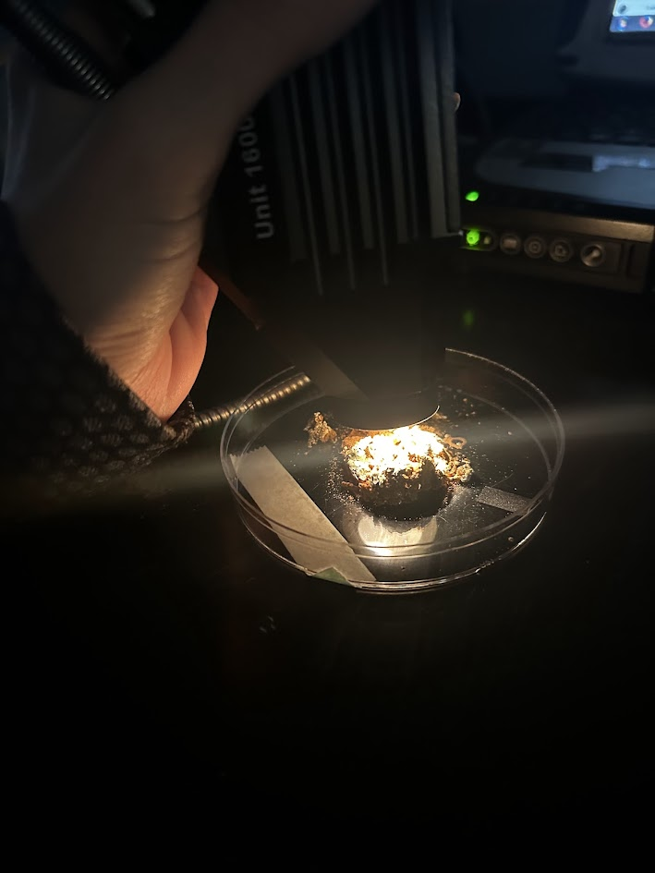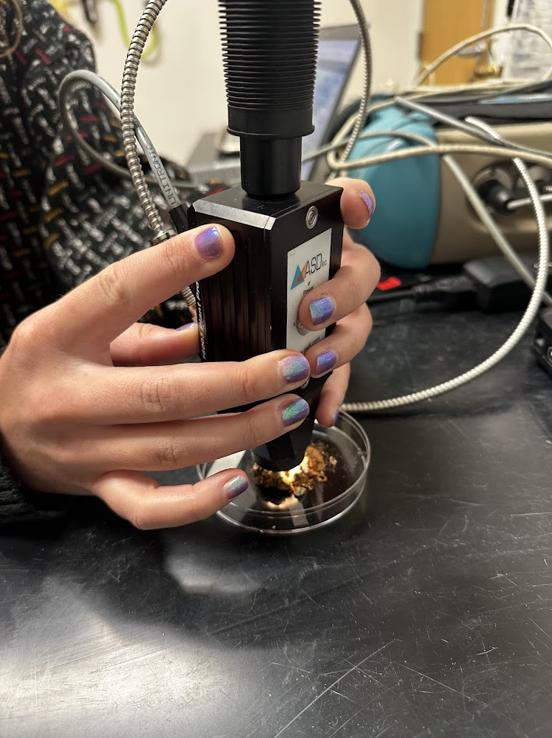
  - 1st reading: Place contact probe over the focal or most representative region of sample (the area with the most intact biocrust for example) and record a reading (press “space” key, spectrum save number should go up by one)
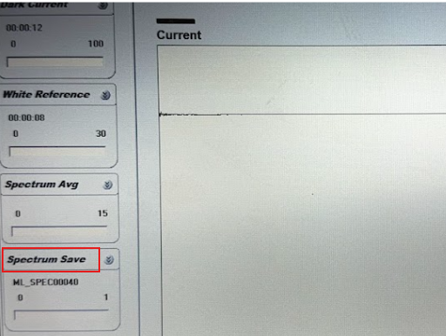
    - The spectra might fluctuate for a moment, wait until the graph stabilizes to record reading
    - Record the file name and number for each reading in data sheet (there’s no other way to associate file name to sample after file is saved)
  - 2nd, 3rd, 4th and 5th readings: shift the angle of the probe while still pointing it at the focal region identified in the first reading (small movements are okay, this is meant to account for small variability in spectral readings)
- Wet sample with spray bottle ~1.8ml of deionized water (roughly two full sprays, may vary depending on the spray bottle). Hold spray bottle close to sample to avoid spraying the petri dish.
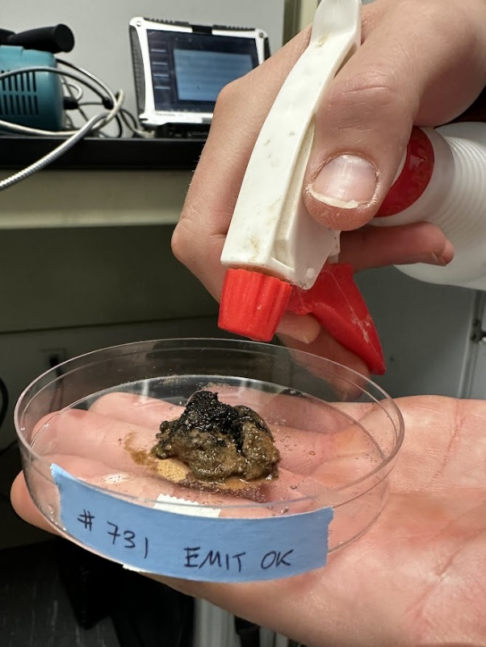
  - Should be visibly saturated but water should not be pooling or beading on the surface of the sample
  - Wipe excess water off petri dish edges if necessary using a ChemWipe
- Take photo number 3 of wet sample
  - Record photo number or label photo on phone
- Repeat “Step 4” for WET Hyperspectral readings

Clean up
- No need to save on the RS3 software, you can just close the software when done collecting.
- Turn instrument off with power switch in the back
- Save Excel sheet
- Let samples fully air dry before storing
  - Biocrust samples should be stored in paper bags or open collection tubes to allow airflow

